

Teaching the Narrative Essay using Chapter 15 of Cannery Row
Teresa Marceaux, English Composition 1010, Sowela Technical Community College,
NEH Steinbeck Institute 2013

Grade Level: College entry level or high school

Overview
- This lesson uses one chapter from Steinbeck’s novel Cannery Row and other selected essays as professional models of narration. After completing the lesson, students will compose a narrative essay of their own.
- This exercise gives entry level college English students the background and skills needed to compose a 550-700 word narration essay. Students will:
  - Become familiar with the definition of “narrative,”
  - Read several professional models of narrative essays, including chapter 15 from Cannery Row,
  - consider their audience and purpose for writing,
  - Organize and draft a narrative, paying particular attention to:
    - Stating a point
    - Using effective transitions
    - Using consistent verb tenses
    - Maintaining a consistent point of view
    - Ordering by plot sequence, chronology, flashbacks, or dialogue
Texts:
- Back To The Lake, 2nd Edition, Chapter 4: Narration, pp. 62-120. (this text is required by the college)
- Cannery Row, John Steinbeck, Penguin Books.

On-line resources:
- Back to the Lake, e-book edition:

http://www.gobookee.net/back-to-the-lake-thomas-cooley/
- “The Sanctuary of School” by Lynda Berry: http://www.prenhall.com/kirszner/pages/ch02.pdf

http://www.humbleisd.net/cms/lib2/TX01001414/Centricity/Domain/2311/sanctuary_school_se.pdf
- “Render Unto Larry’s” by Phil Holland http://www.nytimes.com/2009/07/17/opinion/17iht-edholland.html?_r=0

Teacher-created resources:
- See page 6-9

Procedures:
Day 1:
- Introduction to the narration essay, Back to the Lake, pp.451-63. Narration the storytelling mode of writing, or more simply, telling a story to make a point. Students will become familiar with a general definition of “narrative” and will begin the preliminary steps to composing their own narrative essay. They will begin by considering their purpose for writing and their audience; they will consider or “brainstorm” the Who, What, When, Where, How and Why. By reading and analyzing the student sample and the professional model, students can begin to get a grasp on their own ideas for a narrative essay.
- Back to the Lake, pp. 62-76; in-class read and preview of questions on page 80.
- Back to the Lake, pp. 76-49; in-class read and discussion of Student Sample.
- Outside reading; “The Sanctuary of School,” pp. 84-87. Answer questions on page 88.
Days 2:
- Discussion of outside reading and questions on page 88. Students will discuss why (or even if) they believe this reading, “The Sanctuary of School,” is a good model of narrative. They will analyze its elements and discuss its merits as narrative.
- In-class reading, Cannery Row, Chapter 15, Penguin Edition pp. 81-87. Students will read Chapter 15, which begins with Mack and the boys being entertained by the captain prior to the frog hunt and ends with them leaving the captain’s home in disarray early the next morning. Students will consider the chapter for its effectiveness as a narrative example, using and answering the following questions:
  - Does the story within this chapter serve the purpose it’s intended to serve? Is it appropriate for its intended audience?
  - Is there a plot or some plot development? Is the action in the chapter necessary to the plot? Is more action needed?
  - Does the narrative have a clear point or argument? What is it? Is it stated explicitly? Should it be?
  - Steinbeck uses an anecdote (the frog hunt) as a narrative within the entire episode; does this make the story line difficult to follow? Is his intentional deviation from chronology effective?
  - The frog hunt episode also serves as a metaphor; discuss what the metaphor is. It is a metaphor for the struggle that is life, for the struggle between man and nature, for the battle between the strong and the weak, war, bank failures, just about anything. How can a metaphor be an effective tool in a narrative essay?
  - Are there clear transitions that mark a sequence of events or a departure from that sequence? Do the transitions logically connect the adjoining parts of the narrative?
  - Does Steinbeck’s use of dialogue sound realistic? He uses dialogue to add humor; how effective is this detail?
  - Steinbeck uses many concrete details in this chapter, especially visual and auditory. In what ways do these details help to show action, rather than simply telling?
  - How well does the beginning of the chapter catch the readers’ attention? How well does it set up the action that follows?
  - How satisfying is the ending of the chapter? What does it leave the reader thinking and/or feeling?
- In-class reading; Phil Holland’s “Render Unto Larry’s,” pp. 95-97. Answer questions on page 97-98. Here students will become familiar with a different type of professional narrative model. They will discuss Holland’s purpose, his use of dialogue, and his interesting use of point of view as it relates to the definition of the narrative essay.

Days 3 and 4:
- Handout: The Narration Essay Step-by-Step; choose a topic.
- In-class: composing a rough draft
  - Compose in Word and save to desktop, pin and/or h- drive.
- Back to the Lake,
  - p. 69: “Templates for Drafting”
  - pp. 72-76: Composing the Narrative
- Assignment: Bring 6 printed copies of your first draft to class on Day 6.
Days 5 and 6:
- Writer’s Group – follow protocol. Exchange rough drafts with classmates; give and receive feedback.
- Assignment: revise your first draft; prepare for submission.
Day 7:
- Post final revised draft to teresa.marceaux@sowela.edu no later than end of day Thursday, Sept. 12.

Modern Day Cannery Row

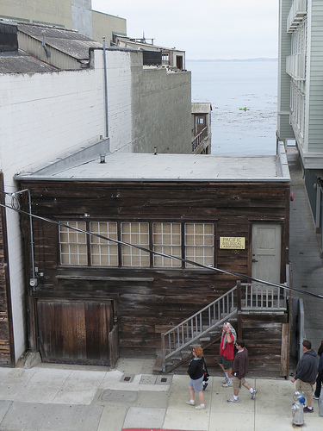
Doc’s Lab, July 2013

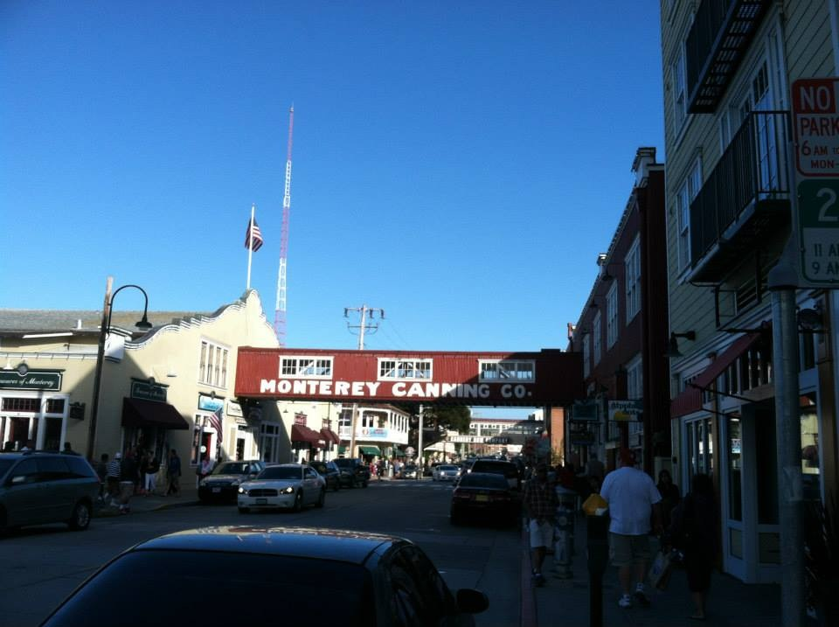
Modern Day Cannery Row, July 2013 Photos courtesy of Justin Czarka

Masters of Teacher Created Materials:
Teresa Marceaux
English 1010 Section RZE
The Narration Essay
Step by Step
Step 1:
Choose from one of the following topics for your Narration essay topic
- Write a personal narrative looking back from some point in the far future on your own life as you hope others will see it. For example, using third person point of view, write your own obituary; or, using first person, assess your life to your great-grandchildren.
- Chapter 15 of Cannery Row Steinbeck uses the frog hunt as a metaphor; write a narrative essay that contains an episode (anecdote) that is also used as a metaphor, possibly some event or episode in your life that meant a great deal to you.
- In Lynda Barry’s essay, “The Sanctuary of School” she uses an anecdote to illustrate her larger argument about the importance of art in school. Write your own anecdote that illustrates your own personal argument about an issue about which you feel very strongly.
- Write a historical narrative tracing the roots of your family or your hometown or community. Include specific detail, dialogue, and descriptions of people and places.
- All families have their stories and legends; write a personal narrative about one of your family’s traditions, stories, or legends.
- Write an account of one of your “firsts”; your first date, first extended stay away from home, experience losing someone close to you, or first time you witnessed the birth of someone close to you.
- Write a personal narrative about a time when you were an outsider, isolated because of social, intellectual, or ethnic differences. Did you resolve the problems your isolation created? Explain.
- Imagine a meeting between any two people who have died and meet in Heaven (or possibly Hell. The people may be either real or fictional characters. Using dialogue and narrative, write an account of their meeting.
- Trace the history of your favorite possession (must be an inanimate object). Use the object’s history to reveal something about yourself and explain why the object is of such value to you.
Step 2:
Compose a rough draft; include the correct format. Make 4 copies for Writer’s Group.

Step 3:
Participate in Writer’s Group to gain feedback on your first draft. Make necessary revisions.

Step 4:
Participate in Peer Review of revised draft. Prepare final draft for submission.

Step 5:
Post your final revised draft to my e-mail before class ends Thursday, Sept. 12. This draft will be graded by me and returned to you with comments.

Writing Group Protocol

Procedure:
- The first Writer volunteers to be in the “Writer’s Chair.” Copies of the Writer’s essay are distributed to the Group; the Writer then reads his piece. Members of the group listen without comment or taking notes.
- The Writer reads the piece aloud a second time as the Group members silently complete the Plus/Delta response.
- The Group members individually read their comments without discussion; the Writer simply listens.
- Group members may then have an informal discussion of the piece; the Writer still just listens without comment.
- After all comments have been shared, the Writer may respond briefly.
Rules for the Writer:
- Give no disclaimers before you begin! Simply read the essay.
- Read slowly and loudly; pause about 30 seconds between first and second reading.
- Simply listen during the time the Group is responding to your piece. You are not to speak, defend or explain your work at this time.
- Take notes during the Group discussion to help you with later revisions.
- Do not feel obligated to use every single suggestion the Group gives.
- Remember that criticism of one piece does not define you as a writer.
- Value the positive feedback you get as much as you do the constructive criticism.
Rules for Group members:
- Take no notes during the first reading, simply listen.
- Write continuously during the second reading.
- Always have at least one positive comment about the piece; conversely, point out at least one area of weakness.
- Try to achieve a balance of support and suggestion.
- Support your suggestions with specific reasons or examples.
- Never tell the writer what he should do.
- Critique the writing, not the Writer. No comments about the Writer’s personality, etc.
- Be specific about your praise and suggestions. Avoid generalities like “That was good,” or “It needs work.”
- Don’t dominate the Group; allow everyone to share suggestions. When you’ve had your turn remain quiet.
Suggested Areas for Comments:
- What was the strongest or most positive aspect of the piece? Where could it have been stronger?
- Comment on diction, syntax, rhetorical strategies used, use of examples, etc.
- What could have been added to make the piece more concise? What could have been left out?
- Are there structure or usage problems that should be corrected?

Plus/ Delta for Writing Group Your Name_________________________
Essay ________________________ Writer’s Name______________________


Plus—what did you find that was good? Delta—where do you see room for improvement?
______________________________________________________________________________

